**Faculty name : Faculty Of Computer Science and Artificial Intelligence**

**course name :** Selected CS-2

**team number** : 3

|  |  |
| --- | --- |
| Id | Name |
| 202000392 | سلمى مجدى على ربيع |
| 202000814 | محمد مجدى محمد عبدالحميد |
| 202000316 | رحمه هاشم داهش عبدالرحمن |
| 202000817 | محمد محمود محمد ابوزيد |
| 202000432 | شروق وليد السيد فرج |
| 202000428 | شروق حسين محمد محمد |
| 201900895 | ندى محمد كامل أحمد |

**Paper details**

**Authors name :** Emrah Irmak

**paper name :** Multi-Classification of Brain Tumor MRI Images Using Deep Convolutional Neural Network with Fully Optimized Framework

**publisher name : Shiraz University**

**year of publication** : Published online: 22 April 2021

**dataset name** : Cheng et al. 2015

**implemented algorithms : Convolution Neural Network (CNN)**

***results***

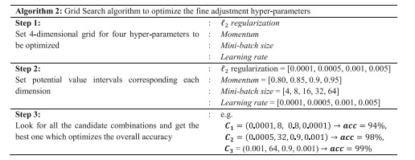

***General Information on the selected dataset***

**name of the dataset**: Brain-Tumor-Classification

**link of data set :** [**https://www.kaggle.com/code/chityeaung/brain-tumor-classification/input**](https://www.kaggle.com/code/chityeaung/brain-tumor-classification/input)

**the total number of samples in the dataset :** 3264

**dimension of images :** (554, 554, 3)

**number of classes and their labels :** 4

glioma_tumor-

-pituitary_tumor

meningioma_tumor-

no_tumor-

***Implementation details***

**ratio used for training, validation, and testing : 3264, 0.8 ,0.1 ,0.1**

**number of images in train : 2610**

**number of images in test:327**

**number of image in validation:327**

***A block diagram***

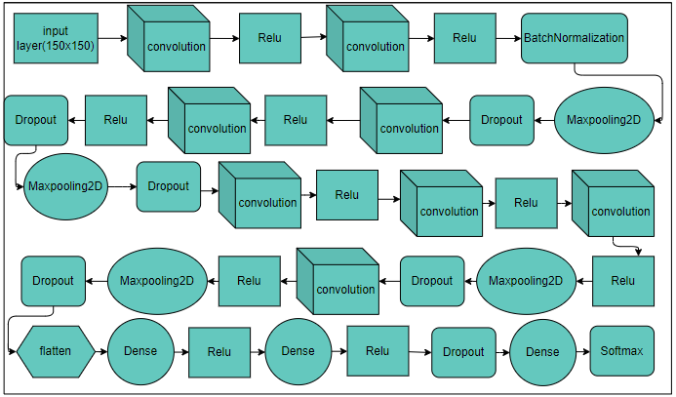

***hyperparameters***

|  |  |
| --- | --- |
| **values** | **hyperparameters** |
| [9,4]  3  32,64,64,64,128,128,  128,128,256  3,2  Relu | Number of convolution and max pooling layers  Number of FC layers  Number of filters  Filter size  Activation function |

***In the paper***

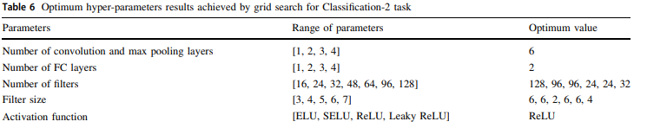

***Results details:***

Specify the measures that are used in evaluation and show all these results for your model on testing data

